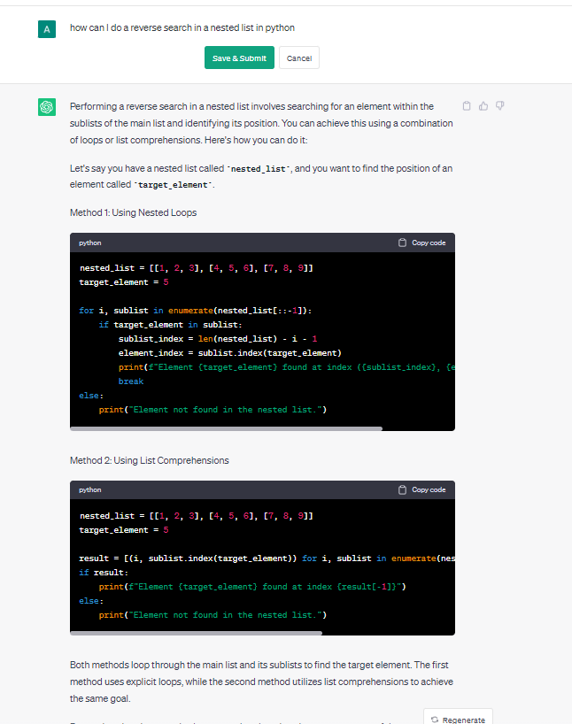

I asked Chat GPT how top reverse search in a nested list and played around with some of the code in its examples. I used its logic and code in line 6 of the first example and refactored it into my code as below to make the same code for the diagonal winning conditions work for the reverse.

diagonal_index_opposite = [play_board[i][len(play_board) -i -1] for i in range(grid_layout)